

**Tribhuvan University**

**Faculty of Humanities and Social Sciences**

Artificial Intelligence

A LAB REPORT

Submitted to

Department of Computer Application

Shahid Smarak College

*In partial fulfillment of the requirements for the Bachelors in Computer Application*

**Submitted by: -**

Amir Maharjan

**Internal supervisor**

Rajesh Shahi Thakuri

**External Supervisor**

**Table of Contents**

**Question – 1 1**

**Question – 2 3**

**Question – 3 5**

**Question – 4 6**

**Question – 5 8**

**Question – 6 10**

**Question – 7 12**

**Question – 8 13**

**Question – 9 14**

**Question – 10 15**

**Question – 11 16**

**Question – 12 17**

**Question – 13 19**

# 

# Question – 1

Write a python program for the implementation of vacuum cleaner.

**Code:**



**Output:**

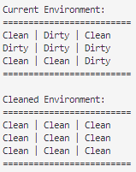

# Question – 2

Write a python program for the implementation of depth first search (DFS).

**Code:**



**Output:**

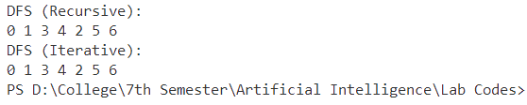

# Question – 3

Write a python program for the implementation of breadth first search (BFS).

**Code:**



**Output:**

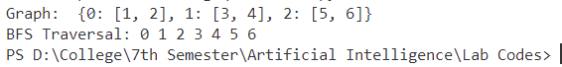

# Question – 4

Write a python program for the implementation of uniform cost search.

**Code:**



**Output:**

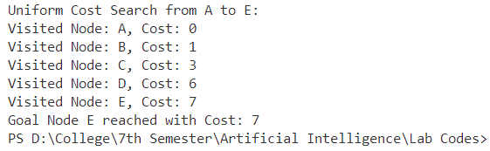

# Question – 5

Write a python program for the implementation of greedy best first search.

**Code:**



**Output:**



# Question – 6

Write a python program for the implementation of A* search.

**Code:**





**Output:**

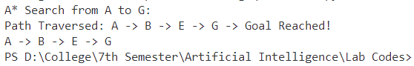

# Question – 7

Write a program to implement logic programming using prolog.

**Code:**



**Output:**

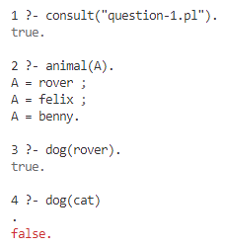

# Question – 8

Write a prolog program to represent few basic facts and perform queries (Elephant is an animal. Elephant is bigger than horse) etc.

**Code:**



**Output:**

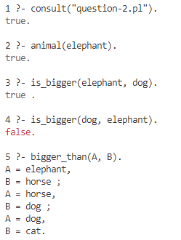

# Question – 9

Write a program in prolog to implement simple arithmetic.

**Code:**



**Output:**

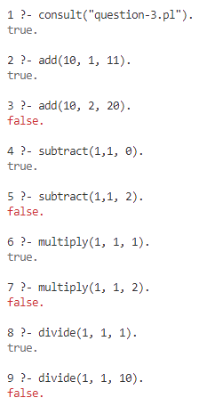

# Question – 10

Write a prolog program to convert the sentences into FOPL and to execute queries

**Code:**



**Output:**

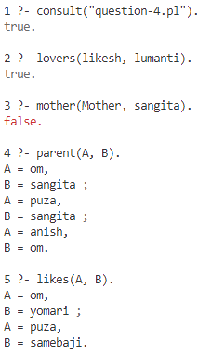

# Question – 11

Write a prolog program to create a knowledge base of sentences and to execute queries.

**Code:**



**Output:**

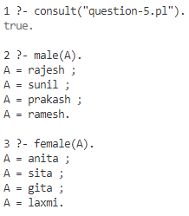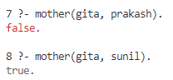

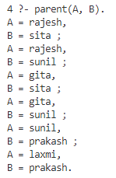 

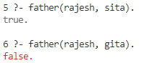

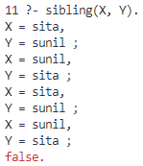

# Question – 12

Write a python program to implement AND, OR gate using perceptron algorithm.

**Code:**





**Output:**

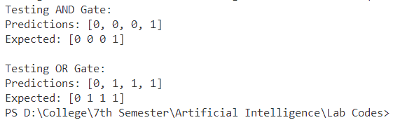

# Question – 13

Write a python program to illustrate working of backpropagation algorithm.

**Code:**





**Output:**

